ORDER OF WORSHIP
* Indicates, please stand if able.
Fourth Sunday of Advent December 24, 2023, 9 am
Liturgist: Katrina McGillivray

WELCOME, PASSING THE PEACE OF CHRIST, & ANNOUNCEMENTS
*CALL TO WORSHIP
L: Glory to God who strengthens us with Christ’s presence, who announces the secret that was kept quiet for a long time.
P: The news this day is all good. We can’t help singing!
L: Christ is coming, God with us. God is eternal, and God is faithful.
P: The news this day is all good. We can’t help singing!
L: We light the candle of peace, rejoicing in God’s presence. Glory to God, who alone is wise. Glory to God, who is coming down to us!
P: The news this day is all good. We can’t help singing!
LIGHTING OF ADVENT CANDLE #4, Channing Goldsmith and Suzanne Goldsmith
Reader 1: When the angel Gabriel visited Mary, announcing God’s plan for her to conceive and give birth to the Messiah, “Mary said to the angel, ‘How can this be, since I am a virgin?’” (Luke 1:34) And yet, only a few months later, Mary sings to Elizabeth,
My soul glorifies the Lord and my spirit rejoices in God my Savior, for he has been mindful of the humble state of his servant. From now on all generations will call me blessed, for the Mighty One has done great things for me—holy is his name (Luke 1:46-49).
Reader 2: We, like Mary, hear God’s call to be part of making God’s dream for our salvation and flourishing a reality, and we question, “How can this be? I am only…” Yet, like Mary, the “onlys” that make us hesitate are gifts God can and will use as God’s love transforms us into bearers of good news.
Congregation: We wait as people who have encountered divine Love that disrupts the status quo and ushers us into abundant life marked by mutual love and peace that flows from the flourishing of all people.
Reader 1: We light these candles as signs of our shocking hope, our just peace, our fierce joy, and the love that transforms us. May Love grow within us, transforming us into bold witnesses of God’s salvation with our voices and our lives. Amen.
CONGREGATION: “Come, O Come, Emmanuel” (v.4) UMH #211
*OPENING PRAYER (Luke 1, Romans 16)
Come to us, Promised One, in this season of waiting. Set our hearts ablaze with the glory of your salvation. Set our minds afire with the richness of your word. Reveal to us the secret of your ways; for you alone are wise, you alone are worthy of our thanks and praise. Through Jesus Christ, our Lord, we pray. Amen

*OPENING HYMN Hail to the Lord’s Anointed UMH #203
CHILDREN'S TIME Rod McGillivray
JOYS AND CONCERNS

PRAYER OF CONFESSION
It’s getting harder and harder to focus on the true meaning of Christmas, the incarnation of God’s love in the birth of God’s Son Jesus Christ. We are caught in the web of festivities, travel, gifts, and glitter. And we have to admit that we really do enjoy all the holiday opportunities. But as we get closer to the big family celebrations and the actual celebration of Christmas, we begin to wonder how we are going to "survive" it all. We say to ourselves, "We won’t let all this stress happen to us next year." But we know better. We allow ourselves to be continually drawn in to the demands of others, leaving little or no time for ourselves, our families, and especially for You, gracious God. Forgive us. You are all too familiar with our reasons and excuses for what is happening. Help us to make some changes in our lives and our focus, so that this time of celebration may have the deepest sense of joy and purpose, not just be the rush and clamor of yet another holiday season that disappears all too quickly. Keep us focused on the eternal "yes" response to your call to us, to live our lives as those who would joyfully serve You. Heal and comfort us, Lord, this day and always. For we ask this in the name of Jesus, our Savior. AMEN.
WORDS OF ASSURANCE (Ephesians 1)
God’s love and faithfulness have been at work in you. You are healed and forgiven. Rejoice in God’s love. AMEN.
PASTORAL PRAYER Rev. Shon
THE LORD’S PRAYER (In Unison)
INVITATION TO THE OFFERING
*DOXOLOGY Praise God, from Whom All Blessings Flow UMH #94
*OFFERTORY PRAYER Rev. Shon
SCRIPTURE Luke 1:46-56
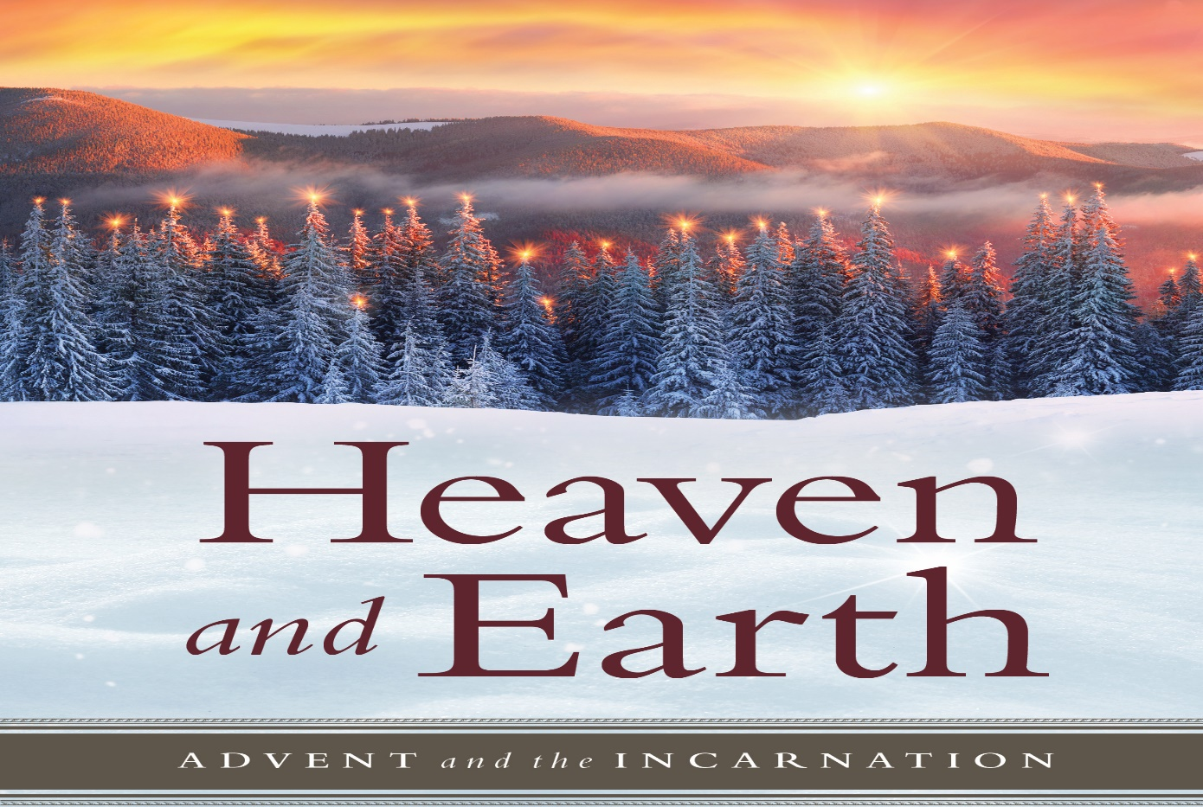
⁴⁶ And Mary said: “My soul glorifies the Lord ⁴⁷ and my spirit rejoices in God my Savior, ⁴⁸ for he has been mindful of the humble state of his servant. From now on all generations will call me blessed, ⁴⁹ for the Mighty One has done great things for me—holy is his name. ⁵⁰ His mercy extends to those who fear him, from generation to generation. ⁵¹ He has performed mighty deeds with his arm; he has scattered those who are proud in their inmost thoughts. ⁵² He has brought down rulers from their thrones but has lifted up the humble. ⁵³ He has filled the hungry with good things but has sent the rich away empty. ⁵⁴ He has helped his servant Israel, remembering to be merciful ⁵⁵ to Abraham and his descendants forever, just as he promised our ancestors.” ⁵⁶ Mary stayed with Elizabeth for about three months and then returned home.
*HYMN OF PRAISE What Child Is This UMH #219

SERMON Rejoice Rev. Shon
*CLOSING HYMN It Came upon the Midnight Clear UMH #218
*BENEDICTION Rev. Shon

ANNOUNCEMENTS
PRAYER REQUESTS: Please pray for people in need in our church, community, nation,
and the World.
STEWARDSHIP CAMPAIGN: for the upgrade of the sound and video system at the
Sanctuary, boilers replacement, and next year’s church budget.
DECEMBER 31ST SERVICE: Rev. Loretta Waughtal will be preaching on December 31st
as Rev. Shon will be on vacation from December 26th to Jan. 3rd.
DINNER CHURCH: Team members wanted. Also looking for a donation of a
small/upright freezer in good working condition. Contact Pat Moe at 715-896-6394
ALTERNATIVE GIVING TREE: Donations may be placed in the offering plate or sent to
the church office. Needed by December 29th to be included in end of year giving.
SNOW SHOVELER: Sidewalks and entrances. Contact Pat Moe at 715-896-6394.
NEW MEMBER CLASS: Beginning January 14, 2024.
SEWING GROUP: January 17, 2024, 10 am to 3:00 pm Sewing Pillowcase Dresses.
USHER/GREETERS: Don and Charlene Galston
FELLOWSHIP: Charlene Galston

UPCOMING MEETINGS

Sun Dec. 24 Christmas Eve Candlelight Service 5:00 pm

BLACK RIVER FALLS
UNITED METHODIST CHURCH

UMC Mission Statement:
"To make disciples of Jesus Christ for the transformation of the world.”

PASTOR Rev. Inwha Shon
PIANIST Joyce Moldenhauer

100 North Fourth Street, Black River Falls, WI. 54615
Phone: 715-284-4114 Office Hours: Monday-Thursday, 9 am-2 pm
Website: brfumc.org YouTube: brfumc
Facebook: Black River Falls United Methodist Church

